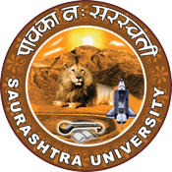
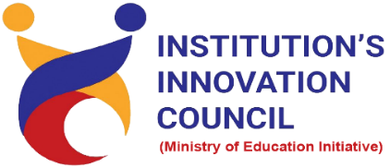
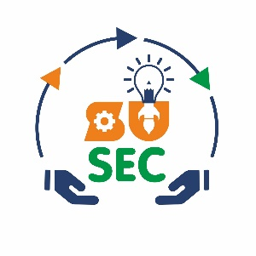
Celebration of National Innovation Day
“How to Start-up”
15 October 2022
At
Department of Chemistry
Saurashtra University Campus, Rajkot
Contents
Saurashtra University – IIC 2
Event Schedule 2
Event Registration Link 2
Brief about Event 3
Key Points 3
Outcome 3
About the Speaker/Chief Guest 4
Connect Us: 5

Saurashtra University – IIC
The university is dedicated to instruction, research, and extending knowledge to the public (public service). Ministry of Education (MoE), Govt. of India has established ‘MoE’s Innovation Cell (MIC)’ to systematically foster the culture of Innovation among all Higher Education Institutions (HEIs). The primary mandate of MIC is to encourage, inspire and nurture young students by supporting them to work with new ideas and transform them into prototypes while they are informative years. Saurashtra University is one the Organization that have constituted the IIC to foster the vision of MoE and be a part for the promotion and development of innovation ecosystem.

Event Schedule

Event Registration Link

bit.ly/HS-UP

Brief about Event

We had celebrated National Innovation Day - 15 October 2022 to spread awareness about conserving innovation by organizing a session on "How to Start-up". Students and Faculty of Saurashtra University participated and celebrated National Innovation Day enthusiastically.
The seminar’s objective is to gain insights about start-ups, entrepreneurship, government funding scheme etc. This involves five stages of start-ups like idea, launch, validation & decision, growth and transition. In this webinar discuss about equation of start-up, essential element of success and also understand start-ups mistakes. India also needs more entrepreneur for start-up growth.
After completion of the workshop, participants are able to acquire more knowledge on How to Start-up?

Key Points

During the session, below mentioned points were discussed:
- Factors effect to start-up
- Equation of start-up
- Five stages of start-ups
- Finding the problems & identify problems
- Start-ups mistakes
- Competitors analysis
- B2B or B2C market analysis
- FAQs related to How to Start-up?

Outcome
As per the event, various types of Start-ups, Importance of Start-ups and Various Start-up Grants was made understood by the speaker.
Also, as it was related to Start-up design and awareness creation, a basic knowledge of how-to Start-up, how it works, how to use Central and state government policies & funding opportunities, with various examples of Start-up etc.

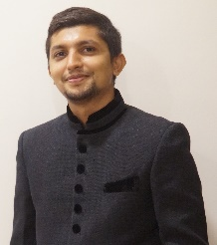
About the Speaker/Chief Guest

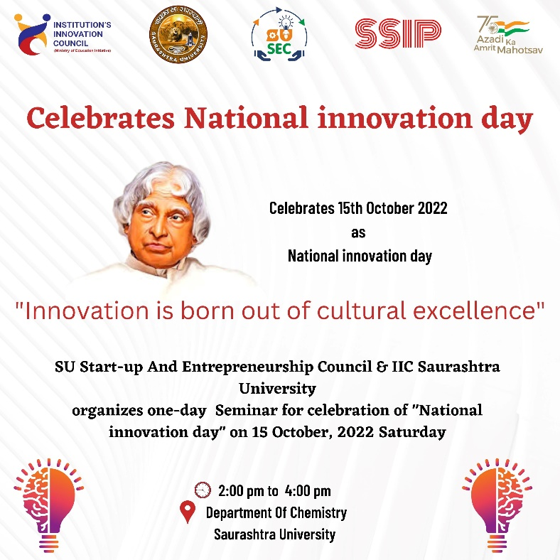

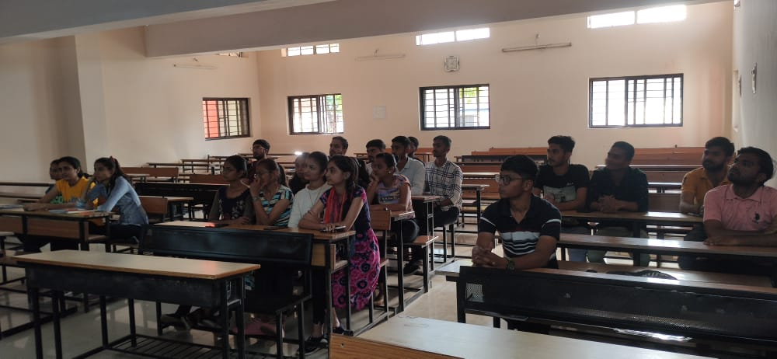
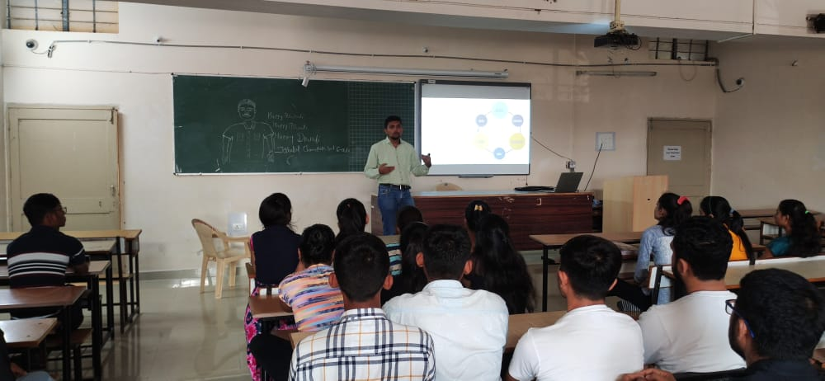

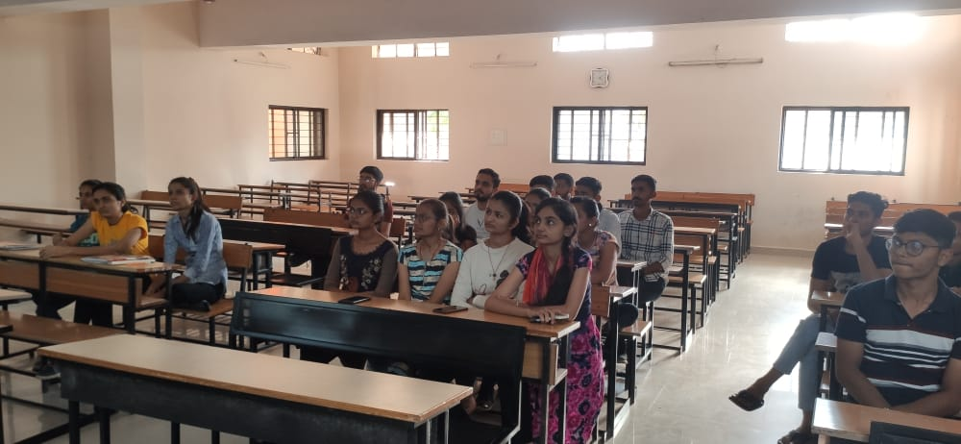
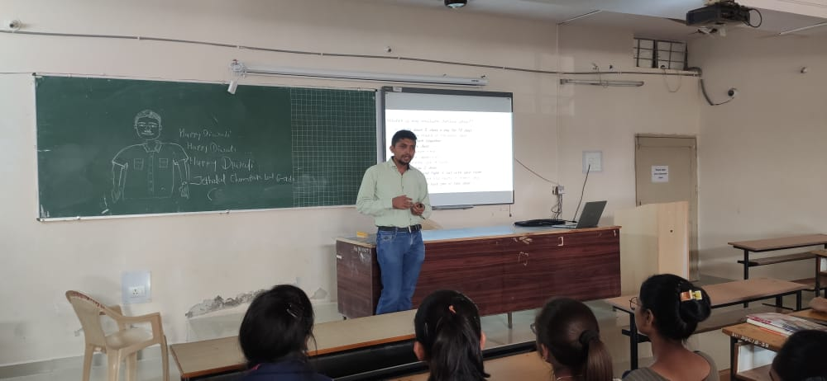

Connect Us:

https://www.linkedin.com/company/susec iic@sauuni.ac.in
https://www.facebook.com/iicsauuni bit.ly/SU-SSIP Location
https://www.instagram.com/susecrajkot https://bit.ly/SUSEC-youtube

